WEEK 3
2520030034
P. Pratik Kumar
- Create a database bookflow
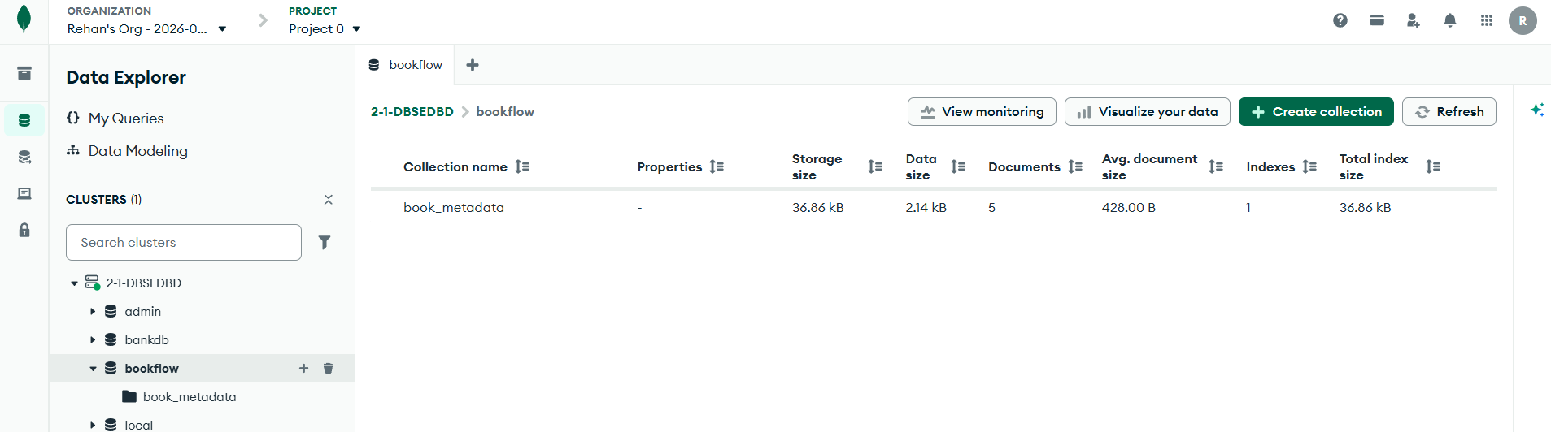
- Create a new collection book_metadata
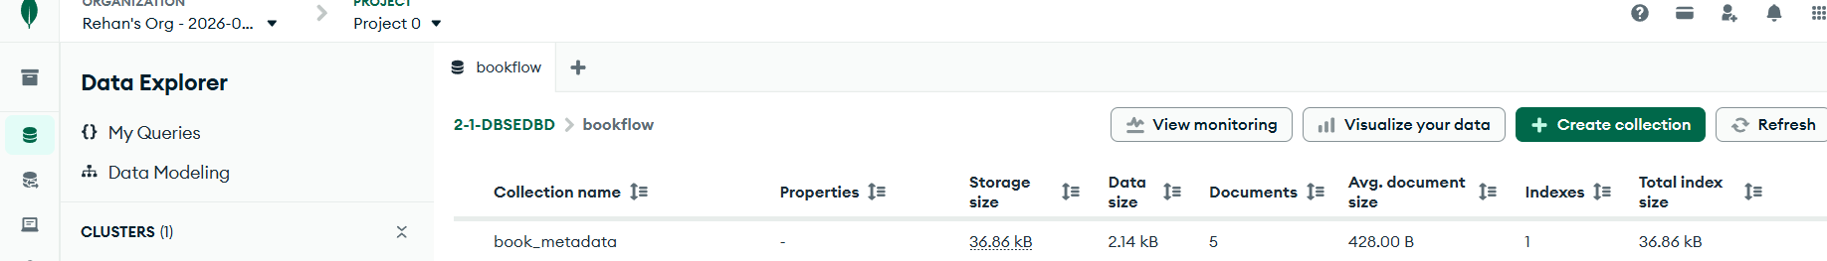
- Click add data and insert documents
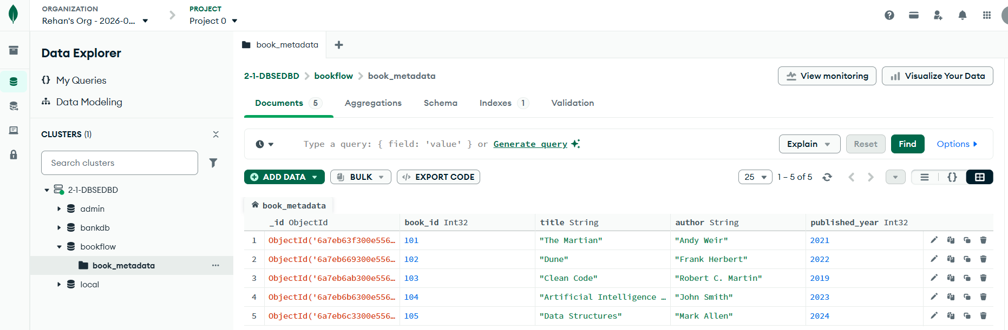
- Mongo DB Queries:
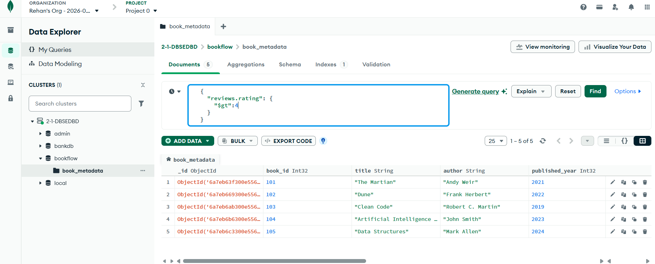
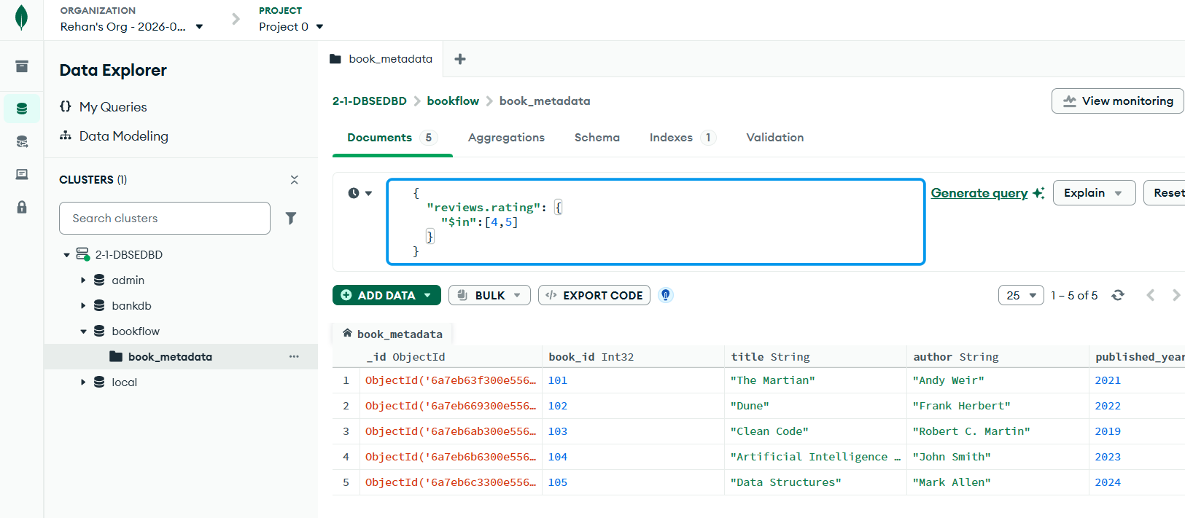

5)Aggregations
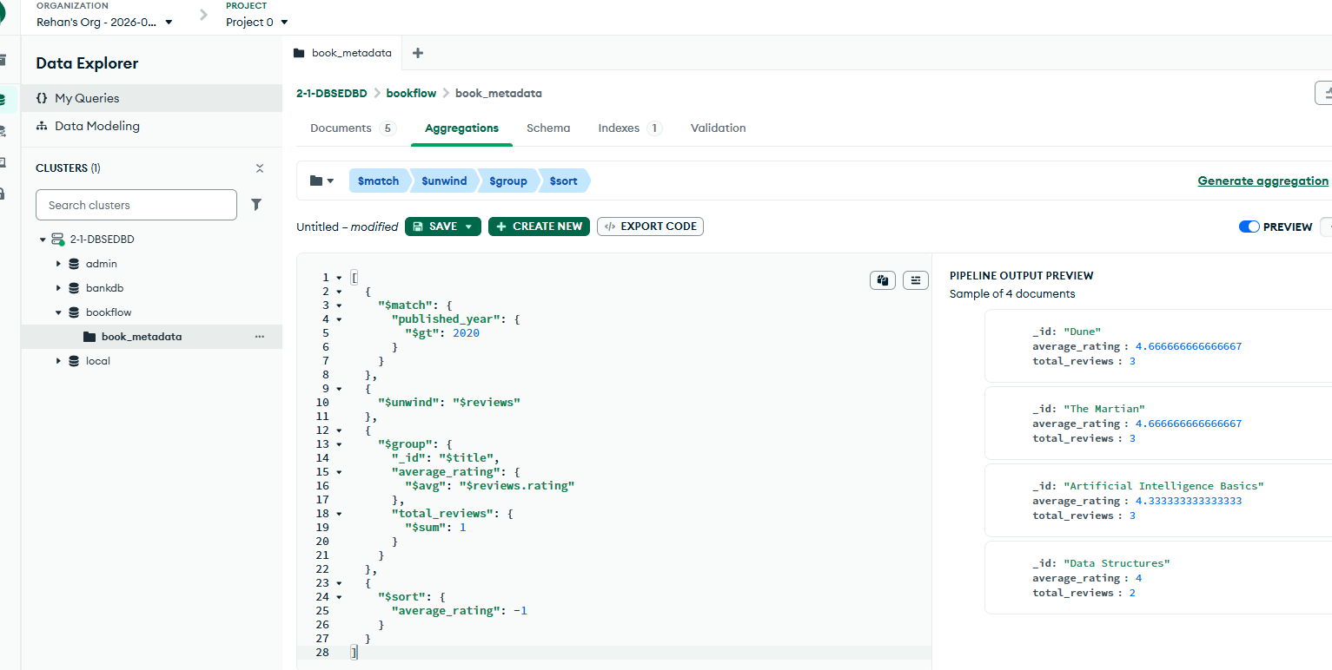

6)Indexes
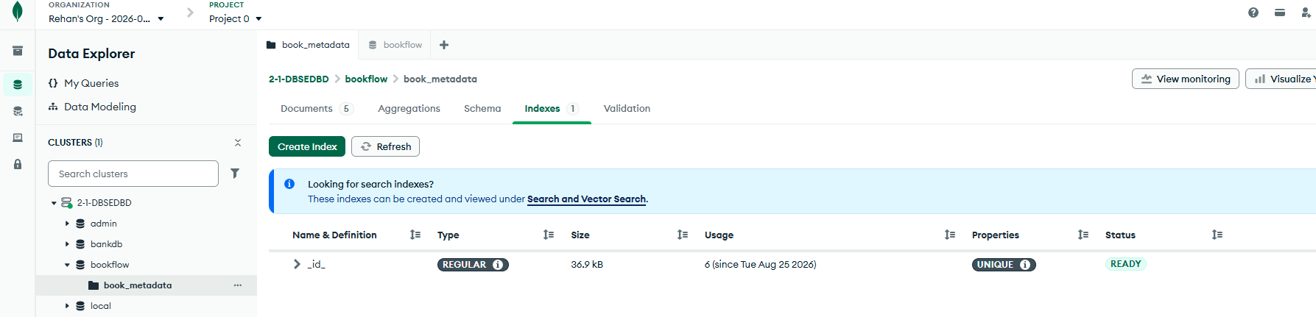

7)Search using text
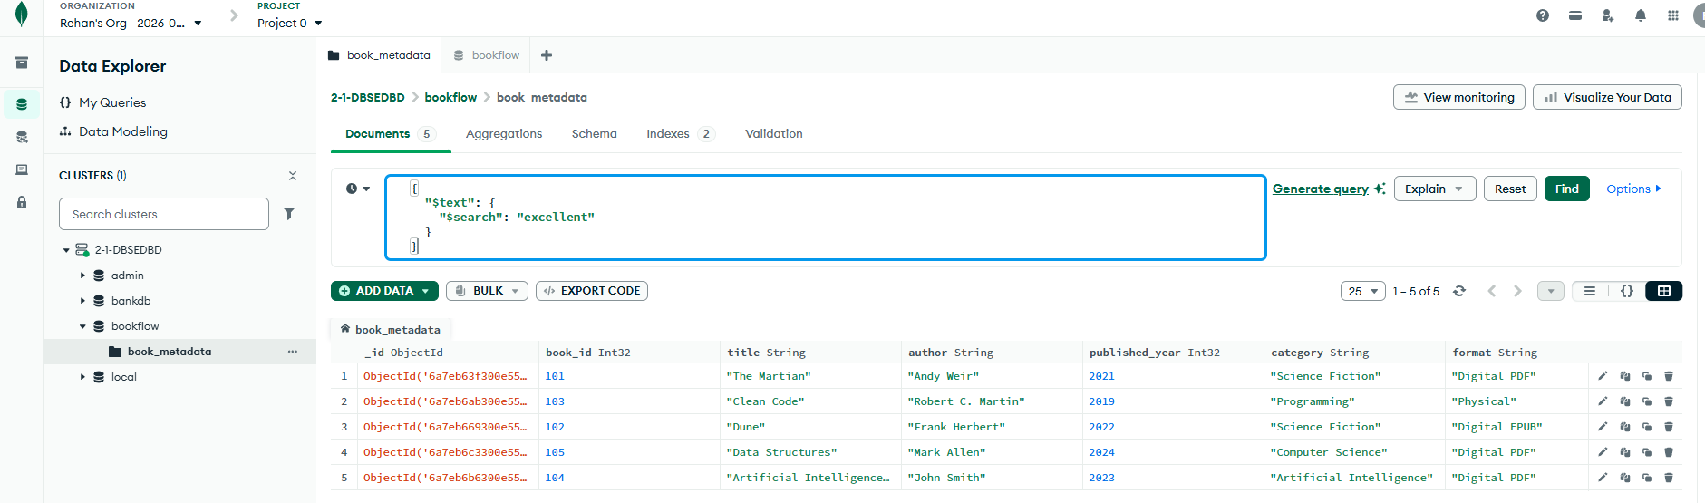
8) Search for a specific word
